Anke Gilleir

**Mann, Erika (1905-1969)**

Erika Mann was the eldest of six children of the German Nobel prize winning author Thomas Mann and his wife Katia Pringsheim. She became well-known as a cabaretière, writer of children's books and most of all as a political journalist who strongly opposed National Socialism. Mann started her career as an actress and came in the spotlight of public attention in 1925 when she played a leading role in *Anja und Esther* (1925, Münchener Kammerspiele), a play written by her brother Klaus about the semi-incestuous relationship between youngsters in a "Erholungsheim für gefallene Kinder" (sanatorium for fallen children). The energetic Mann pursued her career in theatre and film with varying success. In 1928 she made a journey around the world with her brother Klaus about which they wrote the travel account *Rundherum* (All the way round). It was the first of several long journeys through Europe, North Africa and Asia in the following years. Next to being an actress Erika Mann became a prolific writer of reviews, commentaries, and stories for the periodical press of the Weimar Republic. She published her first children's book *Stoffel fliegt übers Meer* (*Stoffel flies over the Sea*) in 1932. As National Socialism rose to power she was determined to swim against the tide. Together with the famous actress Therese Giehse Mann opened up her successful cabaret "Die Pfeffermühle" (the Peppermill) in January 1933 in Munich with a program consisting of songs and sketches mostly written by herself. The Peppermill continued its performances successfully in exile after March 1933 but in the United States, the Mann family's final refuge, the project had to be abandoned. In numerous radio speeches, public addresses and writings Erica Mann crusaded against National Socialism, enhancing public awareness of the brutality of the regime with books such as *School for Barbarians* , *Escape to Life* and *The Other Germany*. She became a war correspondent in 1943 and witnessed the defeat of Germany in 1945, the Nurnberg Trials and the shocking denial of guilt by large parts of the German population. In the following years Erika Mann became the closest collaborator of her father. She dedicated the rest of her life to Thomas Mann's work and image, documented his life in (self-censured) biographical writings and entrusted his legacy after his death.

**References and Further Reading**

Primary texts

*Rundherum* (*All the Way Around,* 1929, not translated in English), with Klaus Mann

*Stoffel fliegt übers Meer* (*Stoffel flies over the Ocean*, 1932, not translated in English)

*School for Barbarians* (1938)

*Escape to Life* (1939)

*The Other Germany* (1940)

*The Lights Go Down* (1940)

*A Gang of Ten* (1942)

*Christoph fliegt nach Amerika. Eine abenteuerliche Luftreise* (*Christoph flies to America. An adventurous Air Trip* 1953, not translated in English)

*Last Year. A Memoir of my Father* (1958, org. 1956))

*The last year of Thomas Mann; a revealing memoir by his daughter* (1958)

*Mein Vater der Zauberer* (*My Father the Magician*, 1996, not translated in English)

*Blitze überm Ozean. Aufsätze, Reden, Reportagen* (*Flashes over the Ocean. Essays, Speeches, Commenatires*, 2000, not translated in English)

Works on Erika Mann

Kröger, U. (2005) *'Wie ich leben soll, weiß ich noch nicht.' Erika Mann zwischen 'Pfeffermühle' und 'Firma Mann'*. Zürich: Limmat.

Von der Lühe, I. (1993) *Erika Mann: Eine Biographie*. Frankfurt/Main (extended and revised as: *Erika Mann: Eine Lebensgeschichte* (2009), Reinbek: Rowohlt)

Weiss, A. (2008) *In the Shadow of the Magic Mountain. The Erika and Klaus Mann Story*, Chicago: University Press.

**Paratextual material**

Visual

Biographical survey of the German Historical Museum: <http://www.dhm.de/lemo/html/biografien/MannErika/index.html>

Photo of Erika and Klaus Mann by Lotte Jacobi (copyright Lotte Jacobi/Wienand Publisher)

[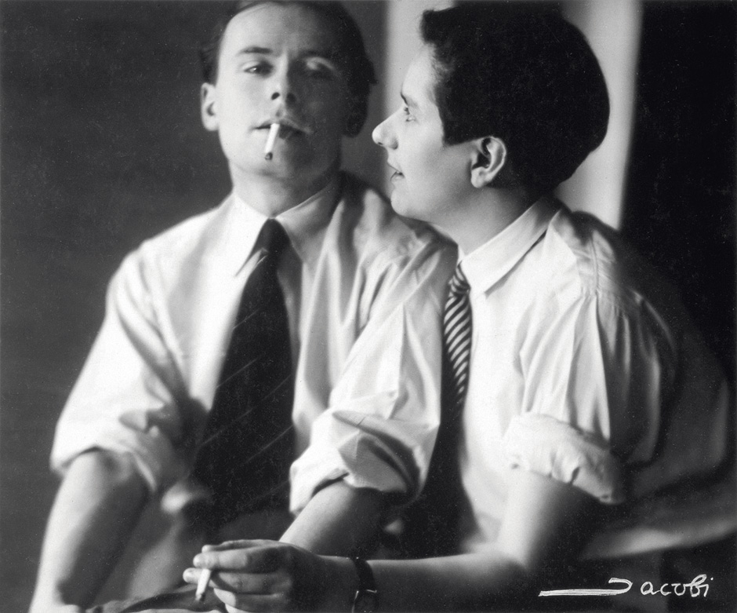](http://www.zeit.de/kultur/kunst/2013-01/fs-lotte-jacobi-photographien/seite-2)